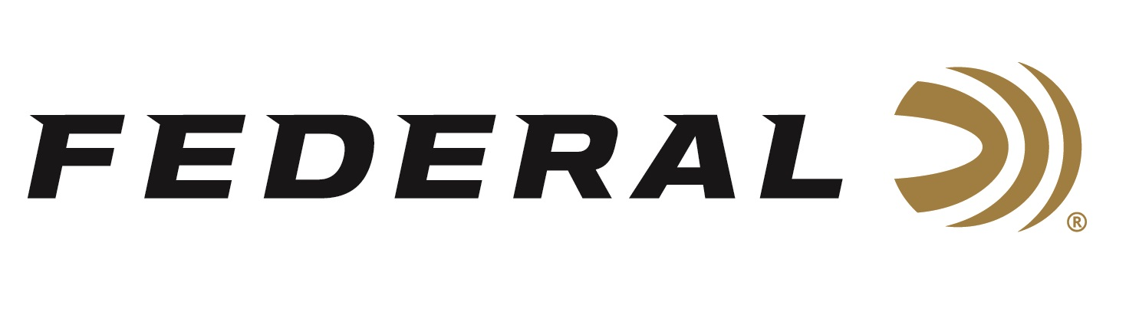

FOR IMMEDIATE RELEASE

Federal Ammunition Introduces New Black Cloud TSS 20 Gauge

ANOKA, Minnesota – June 8, 2020 – Duck and goose hunting entered a deadly new age with the introduction of Black Cloud TSS. Now hunters can get that same performance in a new 20-gauge load that blends No. 3 FLITESTOPPER Steel with No. 9 18 g/cc Tungsten Super Shot. Shipments of this new product have begun to arrive at dealers.

A full 56 percent than lead and more than double the density of steel, TSS pellets maintain velocity farther, hit harder and penetrate deeper than any waterfowl payload ever has. The swarm of shot leaves no chance for escape with the FLITECONTROL FLEX wad, which opens from the rear for a controlled release of the payload and the deadliest, most consistent patterns.

“The hard-hitting TSS pellets make up 60 percent of the payload, our FLITESTOPPER steel pellets make up the remaining 40 percent,” said Federal Shotshell Product Manager Dan Compton. “A raised cutting ridge encircling the exterior gives the pellets an unparalleled ability to slice through feathers and flesh, with no loss of penetration or adverse effect on ballistics and flight characteristics. FLITESTOPPER steel creates significantly larger wound channels than standard round pellets. Coupled with TSS, this blended load delivers extremely impressive results.”

Features & Benefits
- New option pushes 20-gauge effective range to 50 yards
- 60 percent TSS pellets
- TSS is more than double the density of steel and 56 percent denser than lead
- 40 percent FLITESTOPPER Steel
- FLITECONTROL FLEX wad provides the most consistent patterns in all waterfowl chokes
- Reliable primer and clean, fast-burning propellant
- Blended load featuring No. 9 TSS and No. 3 FLITESTOPPER Steel

Part No. / Description / MSRP
PWBTSSX209 39 / 20 gauge 1 ounce 3 inch 3 FS Steel & 9 TSS, 10-count / $38.99

https://www.federalpremium.com/shotshell/black-cloud/

Federal ammunition can be found at dealers nationwide or purchased online direct from Federal. For more information on all products from Federal or to shop online, visit www.federalpremium.com.

Press Release Contact: JJ Reich
Senior Manager – Press Relations
E-mail: VistaPressroom@VistaOutdoor.com

About Federal Ammunition
Federal, headquartered in Anoka, MN, is a brand of Vista Outdoor Inc., an outdoor sports and recreation company. From humble beginnings nestled among the lakes and woods of Minnesota, Federal Ammunition has evolved into one of the world's largest producers of sporting ammunition. Beginning in 1922, founding president, Charles L. Horn, paved the way for our success. Today, Federal carries on Horn's vision for quality products and service with the next generation of outdoorsmen and women. We maintain our position as experts in the science of ammunition production. Every day we manufacture products to enhance our customers' shooting experience while partnering with the conservation organizations that protect and support our outdoor heritage. We offer thousands of options in our Federal Premium and Federal lines-it's what makes us the most complete ammunition company in the business and provides our customers with a choice no matter their pursuit.

